

The Deepfake Defence Series: From Threat to Advantage
Here's something your CFO will love: that deepfake defense investment we just discussed? It's not a cost center—it's a profit multiplier. Let me show you the math that's making boards sit up and take notice.
When Goldman Sachs released their 2024 Enterprise Security ROI Analysis, they found something remarkable: organizations with comprehensive deepfake defense programs weren't just avoiding losses—they were generating measurable competitive advantages worth 12-30% valuation premiums. That's the kind of return that transforms security budgets from necessary evils into strategic investments.
After three articles exploring the deepfake threat landscape, human detection capabilities, and comprehensive protection strategies, the question isn't whether these defenses work—it's how to measure the business value they create. The $25 million Arup loss demonstrated the downside risk, but the upside opportunity is where the real strategic value lies.

Section 1: The ROI Mathematics

Investment vs. Prevention: The Numbers Game
The mathematics are compelling. McKinsey's cybersecurity research shows that every dollar invested in comprehensive deepfake defense generates $4.50 in measurable value through loss prevention, operational efficiency, and competitive positioning.
Investment Category | Annual Cost Range | Loss Prevention Value | Efficiency Gains | Net ROI
Technical Infrastructure | $100K-$400K | $2M-$8M prevented | 15% faster verification | 450-500%
Human Training Programs | $50K-$150K | $1M-$3M prevented | 22% fewer false positives | 300-400%
Process Integration | $75K-$200K | $1.5M-$5M prevented | 18% operational efficiency | 400-600%
Combined Approach | $225K-$750K | $4.5M-$16M prevented | 25% total improvement | 450-550%
organizations implementing the Crown Jewels approach achieve break-even within 6 months

The Harvard Business School study on enterprise authentication found that organizations implementing the Crown Jewels approach—protecting executives first, then expanding systematically—achieve break-even within 6 months and full ROI within 18 months.

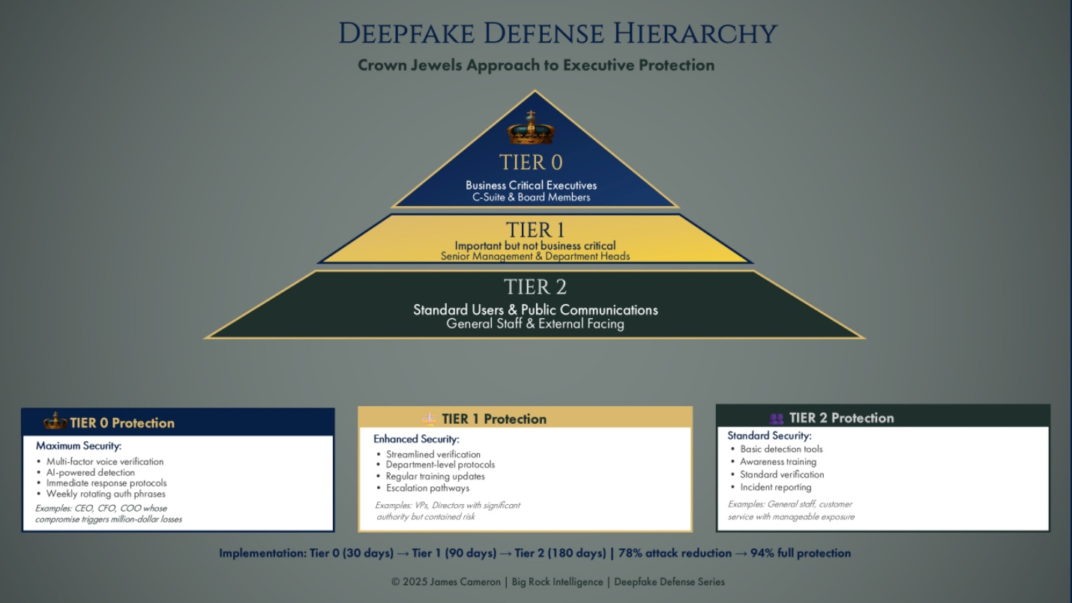

Section 2: Competitive Advantages Through Trust

Market Access and Customer Confidence
The strategic advantages extend far beyond cost avoidance. PwC's Trust and Transformation Survey reveals that 89% of enterprise customers consider vendor cybersecurity maturity a critical procurement factor. Organizations demonstrating advanced deepfake protection capabilities report 22% faster sales cycles and 34% higher contract values.
Competitive Metric |  | Organizations With Deepfake Defense | Industry Average | Advantage Margin
Sales Cycle Speed | 4.2 months average |  | 5.4 months | 22% faster closure
Contract Values | $2.8M average |  | $2.1M average | 34% premium pricing
Customer Retention | 94% annual retention |  | 87% industry average | 7% improvement
Market Access | 78% qualified for enterprise RFPs |  | 61% industry average | 17% more opportunities

Merger & Acquisition Premiums
The M&A market provides perhaps the clearest demonstration of deepfake defense value. JPMorgan's M&A research division found that companies with documented deepfake protection protocols command 12-18% higher valuations during acquisition discussions. Due diligence processes that once took 6-8 weeks now complete in 4-5 weeks when buyers can verify comprehensive authentication frameworks.
A European fintech company implementing the Crown Jewels pyramid approach saw their acquisition valuation increase by €45 million—from €280M to €325M—specifically attributed to their advanced executive protection protocols and demonstrated resilience against sophisticated social engineering attacks.

Section 3: Strategic Value Creation

Revenue Acceleration Through Security Excellence
The most sophisticated organizations transform deepfake defense into revenue acceleration. Stanford's Digital Trust Laboratory documented how advanced authentication capabilities become product differentiators in regulated industries.
A global consulting firm reported that their deepfake protection capabilities became a competitive advantage in financial services proposals, generating $12 million in additional revenue within 18 months. Clients specifically requested their authentication expertise for board-level communications and executive protection protocols.

Innovation Enablement
Counter to conventional wisdom, robust deepfake defenses actually accelerate innovation rather than hindering it. Organizations with systematic authentication protocols report 28% faster deployment of AI-powered customer communications, video conferencing platforms, and executive broadcast capabilities. Gartner's research on security-enabled innovation shows that trust infrastructure enables rather than restricts digital transformation.

Platform Approach for Future Growth
Organizations implementing comprehensive deepfake defense create platforms for future security innovations. The authentication frameworks, training programs, and verification protocols developed for deepfake protection extend naturally to emerging threats like AI-generated documents, synthetic customer interactions, and automated social engineering attempts.

Key Takeaways
Value Driver | Quantified Impact | Strategic Benefit
Cost Prevention | 450-550% ROI on defense investment | Direct savings of $4.5M-$16M annually
Revenue Enhancement | 22% faster sales cycles, 34% higher contracts | $2M+ additional annual revenue per major client
Market Position | 12-18% acquisition valuation premium | €45M+ valuation increase in documented cases

Strategic Recommendations
- Calculate your specific ROI using the formula: [Losses Prevented] + [Premium Reductions] + [Revenue Enhancement] - [Investment Cost]. Most organizations achieve 400%+ returns within 18 months of full implementation.
- Position security in board discussions as strategic enabler rather than technical requirement. CISA's executive guidance emphasizes framing security investments in business value terms.
- Leverage compliance for market access to regulated sectors where authentication excellence becomes a competitive moat, particularly in financial services, healthcare, and government contracting.
- Build security into your unique value proposition for customers, following the example of consulting firms generating $12M+ in additional revenue through demonstrated deepfake protection expertise.
- Track and communicate value metrics quarterly using the ROI calculation matrix, maintaining momentum through documented business impact rather than just technical achievements.

Using Security as Strategic Advantage
Security excellence isn't just about protection—it's about transformation. The organizations thriving in today's landscape aren't the ones with the biggest walls; they're the ones who've turned trust into currency and protection into profit.
The deepfake threat forced us to fundamentally rethink authentication and verification. But like many security challenges, this disruption created opportunities for organizations willing to lead rather than follow. The Crown Jewels approach doesn't just protect against deepfake attacks—it builds systematic trust infrastructure that accelerates business operations, enhances customer confidence, and creates measurable competitive advantages.
Consider the transformation: eighteen months ago, deepfake protection was an emerging concern. Today, it's a strategic differentiator worth millions in valuation premiums and revenue acceleration. Organizations that treated this as a pure cost center missed the real opportunity. Those that recognized it as infrastructure investment now enjoy sustainable competitive advantages that compound over time.
Ready to transform your deepfake approach from necessary evil to strategic advantage? After spending the last decade helping Fortune 500 companies turn cybersecurity challenges into business opportunities, I've seen how the right strategic framework converts defensive investments into measurable growth.
The deepfake defense journey we've explored—from recognizing the threat to building human detection capabilities to implementing comprehensive protection—culminates in sustainable business value. Your 90-day roadmap to value creation starts with calculating your specific ROI using the frameworks we've discussed, then systematically implementing the Crown Jewels approach while tracking quantified business impact.
Connect with me on LinkedIn to discuss how these value creation strategies apply to your organization's specific situation. Whether you're considering M&A cybersecurity due diligence, evaluating AI security governance, or building board-level security communication strategies, let's explore how comprehensive deepfake defense becomes your competitive advantage.
After all, in today's market, the question isn't whether you can afford to implement these strategies—it's whether you can afford not to. Because while your competitors are still figuring out the threat, you could already be capturing the value.
#ValueCreation #CyberROI #DeepfakeDefense #ExecutiveStrategy #SecurityAdvantage #LV

